

**THE IMAGINATION UNIVERSITY PROGRAMME**

**RVfpga-SoC**

**Getting Started Guide**

# 

# Acknowledgments

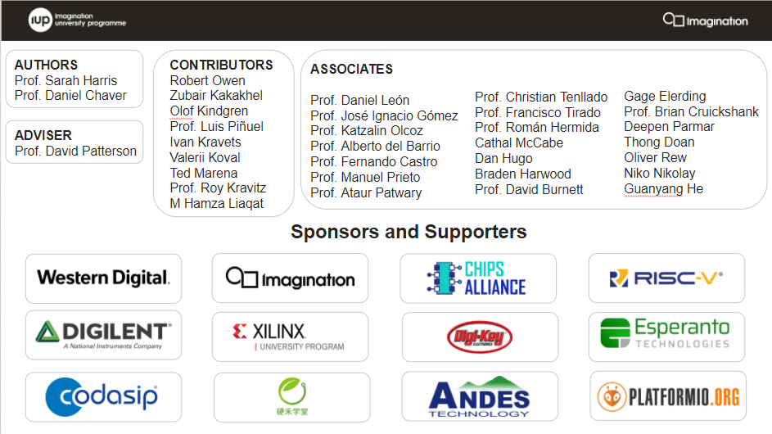

**AUTHORS**

* Prof. Sarah Harris (<https://www.linkedin.com/in/sarah-harris-12720697/>)
* Prof. Daniel Chaver (<https://www.linkedin.com/in/daniel-chaver-a5056a156/>)

**ADVISER**

* Prof. David Patterson (<https://www.linkedin.com/in/dave-patterson-408225/>)

**CONTRIBUTORS**

* Robert Owen (<https://www.linkedin.com/in/robert-owen-4335931/>)
* Zubair Kakakhel (<https://www.linkedin.com/in/zubairlk/>)
* Olof Kindgren (<https://www.linkedin.com/in/olofkindgren/>)
* Prof. Luis Piñuel (<https://www.linkedin.com/in/lpinuel/>)
* Ivan Kravets (<https://www.linkedin.com/in/ivankravets/>)
* Valerii Koval (<https://www.linkedin.com/in/valeros/>)
* Ted Marena (<https://www.linkedin.com/in/tedmarena/>)
* Prof. Roy Kravitz (<https://www.linkedin.com/in/roy-kravitz-4725963/>)
* M.Hamza Liaqat [(https://www.linkedin.com/in/muhammad-hamza-liaqat-ab73a0195/](https://www.linkedin.com/in/muhammad-hamza-liaqat-ab73a0195/))

**ASSOCIATES**

* Prof. Daniel León ([www.linkedin.com/in/danileon-ufv](http://www.linkedin.com/in/danileon-ufv))
* Prof. José Ignacio Gómez (<https://www.linkedin.com/in/jos%C3%A9-ignacio-gomez-182b981/>)
* Prof. Katzalin Olcoz (<https://www.linkedin.com/in/katzalin-olcoz-herrero-5724b0200/>)
* Prof. Alberto del Barrio (<https://www.linkedin.com/in/alberto-antonio-del-barrio-garc%C3%ADa-1a85586a/>)
* Prof. Fernando Castro (<https://www.linkedin.com/in/fernando-castro-5993103a/>)
* Prof. Manuel Prieto (<https://www.linkedin.com/in/manuel-prieto-matias-02470b8b/>)
* Prof. Christian Tenllado (<https://www.linkedin.com/in/christian-tenllado-31578659/>)
* Prof. Francisco Tirado (<https://www.linkedin.com/in/francisco-tirado-fern%C3%A1ndez-40a45570/>)
* Prof. Román Hermida (<https://www.linkedin.com/in/roman-hermida-correa-a4175645/>)
* Cathal McCabe (<https://www.linkedin.com/in/cathalmccabe/>)
* Dan Hugo (<https://www.linkedin.com/in/danhugo/>)
* Braden Harwood (<https://www.linkedin.com/in/braden-harwood/> )
* David Burnett (<https://www.linkedin.com/in/david-burnett-3b03778/>)
* Gage Elerding (<https://www.linkedin.com/in/gage-elerding-052b16106/>)
* Brian Cruickshank (<https://www.linkedin.com/in/bcruiksh/>)
* Deepen Parmar (<https://www.linkedin.com/in/deepen-parmar/>)
* Thong Doan (<https://www.linkedin.com/in/thong-doan/>)
* Oliver Rew (<https://www.linkedin.com/in/oliver-rew/>)
* Niko Nikolay (<https://www.linkedin.com/in/roy-kravitz-4725963/>)
* Guanyang He (<https://www.linkedin.com/in/guanyang-he-5775ba109/>)
* Prof. Ataur Patwary (<https://www.linkedin.com/in/ataurpatwary/>)

**Table 1. RVfpga Terms**

|  |  |
| --- | --- |
| **Name** | **Description** |
| **Courses** | |
| **RVfpga** | A course that shows how to use RVfpga and RVfpgaSIM, RISC-V system-on-chips (SoCs), to run programs and extend the system by adding peripherals (RVfpga Labs 1-10), and explore the core and memory system by running simulations, measuring performance, adding instructions, and modifying the memory system (RVfpga Labs 11-20). Throughout the course, users are also shown how to use the RISC-V toolchain (compilers and debuggers) and simulators, the Verilator HDL simulator, and Western Digital’s Whisper instruction set simulator (ISS). |
| **RVfpga-SoC** | A course that shows how to build the SweRVolf, RVfpga, and RVfpgaSIM SoCs from scratch using building blocks such as the SweRVolf core, memories, and peripherals. The course also shows how to load the Zephyr real-time operating system (RTOS) onto SweRVolf and RVfpga and run programs on top of the operating system. |
| **Cores and SoCs** | |
| **SweRV EH1 Core** | Open-source commercial RISC-V core developed by Western Digital. |
| **SweRV EH1 Core Complex** | SweRV EH1 core with added memory (ICCM, DCCM, and instruction cache), programmable interrupt controller (PIC), bus interfaces, and debug unit. |
| **SweRVolf** | An open-source SoC built around the SweRV EH1 Core Complex. It adds a boot ROM, UART interface, system controller, interconnect (AXI Interconnect, Wishbone Interconnect, and AXI-to-Wishbone bridge), and an SPI controller. |
| **SweRVolf Nexys** | The SweRVolf SoC targeted to the Nexys A7 board and its peripherals. It adds a DDR2 interface, CDC (clock domain crossing) unit, BSCAN logic (for the JTAG interface), and clock generator. |
| **SweRVolf sim** | The SweRVolf SoC with a testbench wrapper and AXI memory intended for simulation. |
| **RVfpga** | Also referred to as *the RVfpga SoC*. A RISC-V SoC that extends the SweRVolf Nexys SoC by adding a GPIO interface, a PTC (PWM/timer/counter), and an additional SPI interface. |
| **RVfpgaSIM** | SwerVolf sim extended to add the RVfpga peripherals (GPIO, PTC, and additional SPI). This module is intended for simulation. |

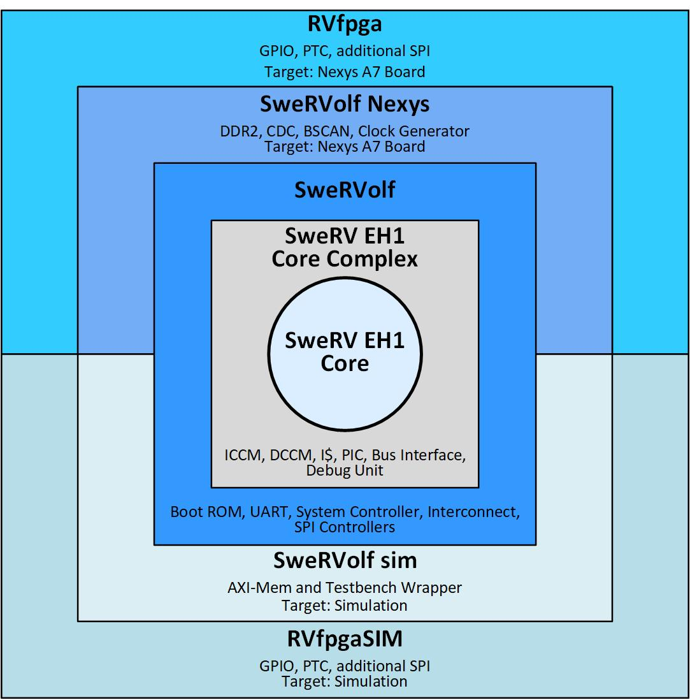

**Figure 1. RVfpga hierarchy**

# RVfpga-SoC Labs Overview

This RVfpga-SoC course shows how to build a RISC-V SoC from scratch using provided building blocks and a visual block-based design approach. The building blocks include the SweRV EH 1 CPU core, interconnect, boot ROM, UART, timer, and GPIO controllers. The SoC created by the user using the block design approach is a close equivalent of the SweRVolf SoC. Subsequent labs show how to run programs on the SoC, compare the block design SoC with SweRVolf, and run the Zephyr real-time operating system on the SweRV SoC.

RVfpga-SoC labs have been built with the following platform:

* Operating System: Ubuntu 18.04 LTS
  + Labs 1 and 2 can be easily run on Windows 10. Labs 3 and 4 use some packages that run in a Linux environment only.
* Hardware Target (optional): Nexys A7-100T board (or Nexys 4 DDR board)
* Full system simulator: Verilator

Before starting RVfpgaSoC Labs, you must have already completed the RVfpga SoC Installation Guide. The Installation Guide has been divided into instructions needed for each Lab. The structure of the Installation guide is as follows:

* **Installation for Lab 1:** Installation of Vivado 2019.2 Web Pack, cable drivers, and Digilent board files.
* **Installation for Lab 2:** Installation of Visual Studio Code (VScode), PlatformIO, Verilator version 4.106, and GTKWave.
* **Installation for Lab 3:** Installation of FuseSoC, and OpenOCD.
* **Installation for Lab 4:** Installation of Zephyr dependencies, west, CMake, and Zephyr SDK version 0.12.2.

If you have already completed the RVfpga course, you will have already installed much of this software.

Make sure that you have copied the ***RVfpgaSoC*** folder that you downloaded from Imagination’s University Programme to your machine. We will refer to the directory’s absolute path to place folder RVfpgaSoC as [*RVfpgaSoCPath*]. Preferably place the **RVfpgaSoC** folder in your home directory. i.e : /home/{username}/RVfpgaSoC

The following labs are provided:

* **Lab 1**: Introduction to RVfpgaSoC
* **Lab 2**: Running Software on RVfpgaSoC
* **Lab 3**: Introduction to SweRVolf and FuseSoC
* **Lab 4**: Running Zephyr on SweRVolf

These labs show how to create an SoC from a core and other building blocks (Lab 1), how to target it to an FPGA and run programs on RVfpgaSoC (Labs 2), how to use a FuseSoC-based SoC for SweRV EH1 (Labs 3), and how to add a real-time operating system (RTOS) to RVfpgaSoC (Lab 4).

The organization of the RVfpgaSoC/Labs/ folder is as follows:

* **Lab Instructions:** Instructions for each lab.
* **LabProjects:** The folder where you will create projects.
  + Lab1: Directory for Lab 1 Vivado Project.
  + SweRVolf: Directory for Labs 3 and 4
* **LabsResources:** Resources you will use during Labs 1 to 2.
* **LabsSolutions**

**Instructors should remove this folder before distributing RVfpgaSoC to students**.